Pokhara University

Level: Bachelor | Semester – Spring | Year : 2008
Programme: BE |  | Full Marks: 100
Course: Numerical Methods |  | Time : 3hrs.

Candidates are required to give their answers in their own words as far as practicable.
The figures in the margin indicate full marks.

Attempt all the questions.

 | - Find out at least one real root of x³ + x² – x – 1 = 0 using Secant method to three decimal places.  - Find out all real roots of the following non linear equation using Newotn Raphson method.  x log₁₀x = 1.2 | 7  8
- The following set of data represent the position of a car in a road at specified time, Calculate the position of the car at T = 1.75 hours. (You can use any method)
Time(hr) | 0 | 0.5 | 1.0 | 1.5 | 2.0
Position(km) | 0 | 0.25 | 1.0 | 2.25 | 4.0
- For the following set of data, fit a linear curve using Least Square Method and find f(2).
x_{i} | 0.5 | 1.5 | 4.5 | 7.5
f(x_{i}) | 2.5 | 3.5 | 6.5 | 9.5

 | - Integrate the given integral  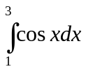  Using trapezoidal, simpson's and rule.  - Using two and three point Gauss Legendre formula. Evaluate  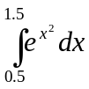 | 7  8
 | - Solve the following system of linear equation using Gauss Elimination method.  2w + x + 3y – z = 9  -3w + x – 2y + z = -4  w + 2x – y + 2z = 5  3w – x – y + 2z = 1  - Find the largest Eigen-value and the corresponding Eigen-vector of the following square matrix using Power method.  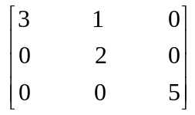 | 8  7
 | - Find the value of y at x = 2.0 for the following initial value problem by using RK – 4 method.  y' = x + y²; y(1) = -0.8, step size h = 0.5  - Solve 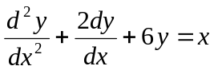, with y(0) = 0, y' (0) = 1 for y(0.2) taking h = 0.2 by RK2 method. | 8  7
 | - Solve the Poisson equation ▼²f=2x²+ y, over the square domain  1≤x ≤4, 1≤y ≤4, with f=0 on the boundary. Take h=k=1  - Using Gauss Jordan method, find the inverse of the matrix  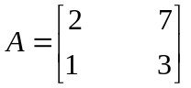 | 10  5
 | Write short notes on (Any Two)  - Errors in numerical computing  - Cubic spline interpolation  - Solution of differential equation by pi card's method | 2×5

